**Kansas City International Airport Terminal**

**Single Terminal Design Selection**

**Final Report**



**Midland Consulting (Team 1):**

**Blake Conrad**

**Bonnie McIlrath**

**Cathy Miller**

**Doug Serota**

**Shaun Wild**

Table of Contents

Chapter 1 – Introduction 4

Purpose. 4

Background. 4

Problem. 5

Stakeholders. 5

Airport Selection Committee. 5

Airport Selection Committee Goals. 6

Chapter 2 – Methodology 7

Purpose. 7

Constraints, Limitations, and Assumptions. 7

Methodology. 7

Chapter 3 – Alternatives 9

Purpose. 9

Minimum Design Criteria. 9

Alternative 1–Functional, Compliant Design. 10

Alternative 2–Iconic, Compliant Design. 11

Alternative 3–Functional, Reduced Compliant Design. 11

Alternative 4–Iconic, Reduced Compliant Design. 12

Data Screening and Refinement. 13

Chapter 4 – Model Development 15

Purpose. 15

Objectives and Decision Criteria. 15

Importance Weights. 16

MCDM Model. 18

Chapter 5 – Initial Results 21

Purpose. 21

Raw Data Scores. 21

Initial Results. 22

Chapter 6 – Sensitivity Analysis 25

Purpose. 25

Sub-Objective Weights. 25

Metric Weights. 26

MCDM Method. 28

Chapter 7 – Conclusion 31

Purpose. 31

Summary of Findings. 31

Summary of Project Team Lessons. 31

Appendix A. Study References 33

Appendix B. Glossary 35

**List of Tables**

Table 1. Alternatives. 9

Table 2. Sub-objectives and Decision Criteria. 16

Table 3. Sub-objective Importance Weights. 17

Table 4. Weighting Scheme. 18

Table 5. Rata Data Scores. 22

Table 6. Weighted Normalized Scores. 23

Table 7. TOPSIS Results. 24

Table 8. TOPSIS Model with New Sub-objective Weights. 25

Table 9. TOPSIS Model with New Metric Weights. 27

Table 10. Sensitivity to Functional 25 Baggage Operations Reduced Score. 28

Table 11. Sensitivity to Functional 25 Cost Increase. 28

Table 12. Final Design Rankings and TOPSIS Scores. 31

Table 13. Rules for MCDM Problems. 32

**List of Figures**

Figure 1. Methodology. 8

Figure 2. Alternative 1 Design (Profile). 10

Figure 3. Alternative 1 Design (Overhead). 10

Figure 4. Alternative 2 Design (Profile). 11

Figure 5. Alternative 2 Design (Overhead). 11

Figure 6. Alternative 3 Design (Profile). 12

Figure 7. Alternative 3 Design (Overhead). 12

Figure 8. Alternative 4 Design (Profile). 13

Figure 9. Alternative 4 Design (Overhead). 13

Figure 10. Recommendation Sensitivity to Sub-Objective Weights. 26

Figure 11. Recommendation Sensitivity to Metric Weights. 27

Figure 12. TOPSIS and SAW Results Comparison. 29

Figure 13. TOPSIS and PROMETHEE Results Comparison. 30

# Chapter 1 – Introduction

## Purpose.

For a several years, Kansas City, MO, has been aware of traffic flow and congestion issues with its main airport, Kansas City International (KCI). This influenced city leaders to engage the aviation department at KCI, the airlines, and voters about the airport’s future and overall representation of the city. The intent is to understand the problem comprehensively, assess all feasible options, and determine the best option for the future of KCI and Kansas City.

## Background.

Originally named the Mid-Continent International Airport, KCI was completed in 1972. It was designed to provide passengers with convenient curb to gate access and serve as an international hub of the supersonic jet age (“Terminal Master Plan”, 2015). Just months after completion, acts of terrorism drove the US government to require passenger security screening at airports. The KCI Aviation Department added security checkpoints in the 1970s; however, the same basic design remained in place (“The Why of KCI”, 2014). The next greatest change to airports at large was in 2001, after the tragedy of 9/11, when the US invoked the Aviation and Transportation Security Act. This act created the Transportation Security Administration (TSA) (“Transportation Security Administration”, 2013) and included the requirement for an entire security screening process prior to entering gates.

Unfortunately, the convenient design of KCI was not amenable to a comprehensive passenger screening process, causing bottlenecks and disruptions to the customers. Additionally, the gate areas beyond security lacked basic customer services such as restrooms and dining options. To date, the airport authority has completed several remodeling projects to expedite the passenger screening process and enhance the experience of customers in the gate areas. Although the upgrades mitigated some of these issues, customers continue to rate KCI at two on a ten-point scale in terms of airport quality (“Kansas City Airport Customer Reviews”, 2017). Not only have customers been complaining, but the airlines have, too. Airlines complain that the KCI gates are inaccessible to big aircraft and the baggage facilities quickly become overwhelmed on the planeside. The claim by airlines is that this has become a serious problem and if left unattended will become a security hazard.

In 2016, the throughput of KCI included 5.5 million passengers, 3,300 tons of mail, and 101,930 tons of freight (“Kansas City International Airport”, 2016). Kansas City, MO, has projected the 2030 passenger throughput to increase 30.1% and freight throughput 2.3% (“Terminal Area Master Plan”, 2015). This increased traffic flow will only compound the congestion and bottlenecks at KCI. The growing challenges in operating KCI have caused the KCI Aviation Department to identify and propose options for long-term operating improvements to KCI.

KCI is owned by Kansas City, MO, and is operated by the Kansas City Aviation Department. In 2016, the Aviation Department and airline partners recommended a single terminal to the city council of Kansas City, MO. Having the same concerns, the city council agreed and worked with the KCI Aviation Department to release a request for proposals for potential solutions. On September 6th, 2017, the KCI Aviation Department selected Edgemoor as the contractor for the new KCI design. When the voters approved the move for a new terminal on November 7th, the only question left is, “What design should the Kansas City Aviation Department select?”

## Problem.

In recent years, security requirements, increased passenger throughput, and costs have diminished the convenience and passenger experience, while airline operations have become more complex and economically challenging. What airport design provides the best value to customers while enabling efficient and effective airport operations?

## Stakeholders.

The second and third order political, social, and economic effects of a business restructuring are vast. The direct stakeholders for KCI include but are not limited to:

* Greater Kansas City area residents.
* Through-traveling passengers.
* Local and international businesses.
* Construction companies.
* Airlines.
* City Council.
* Kansas City Aviation Department.
* KCI Airport Selection Committee.

Customers of KCI and those passing through will see and experience the direct impacts of the redesign. Their interests include shorter lines, less time at security checkpoints, more concession options, better and more bathrooms, and decreased ground transportation wait times. Nearby residents are not so much interested in the interior ‘look and feel’ associated with the terminal, but more-so the taxes and fees they will incur to pay for the new airport. Companies in business with KCI also have direct interest in the redesign, as the restaurant and retail space may expand or contract. This may also open up windows of opportunity for local businesses to introduce themselves. The construction companies themselves see an opportunity to grow their businesses by participating in the KCI redesign/rebuild project. The airlines are interested in airport layout and operations efficiency, which directly affect their revenue streams. The city council and the Aviation Department have made their interests clear: a more flexible and robust layout, a more customer friendly experience, an overall source of community pride, and a financially feasible option.

## Airport Selection Committee.

The Airport Selection Committee is composed of six voting members; these members are:

1. Troy Schulte – City Manager
2. Jolie Justus – City Council Airport Committee Chairperson
3. Jermaine Reed – City Council Transportation & Infrastructure Chairperson
4. Pat Klein – Aviation Director
5. John Green – Aviation Department Chief Financial Officer
6. Phil Muncy – Deputy Director of Aviation for Planning & Engineering

## Airport Selection Committee Goals.

The KCI Aviation Department established an Airport Selection Committee to select a new airport design and contractor. The selection committee will also determine the necessary objectives, criteria, and importance ratios necessary to define what matters most to the city and KCI[1]. While united in spirit, the diversity in interest amongst the board is broad. An understanding of each member’s particular interests is necessary prior to gaining an understanding of the Airport Selection Committee’s consensus goals.

Kansas City has a council-manager form of government. The city’s chief administrator is responsible for making city government run efficiently and economically (“About the City Manager”, 2017). In 2009, the mayor and city council appointed Troy Schulte as acting city manager. Schulte’s interest on the selection committee includes the flow and layout of KCI in light of the taxpaying citizens and customers, operating efficiency, and economic soundness.

Jolie Justus represents Kansas City’s 4th District. For the 2015-2019 council term, Justus is the Chair of the Airport Committee (“4th District Councilwoman”, 2015). Justus’ interests include collaboration between appropriate finances, logical operations flow, and the city’s overall reflection from the implemented changes. Jermaine Reed represents Kansas City’s 3rd District.

For the 2015-2019 council term, Mayor Sly James has appointed Reed to serve as Chairman of the Transportation & Infrastructure Committee (“City Council Members”, 2015). Reed’s interests include passenger and operations flow, the introduction of small businesses, and an airport design that reflects Kansas City’s culture.

Pat Klein is the aviation director for KCI. Klein is aware of many inconsistencies and the challenges of airport operations, making his primary interests landside and airside operations (“City Appoints Patrick”, 2016). Klein has made his opinions clear that without a new terminal design, the bottlenecks and overflow will become very problematic for KCI. With this, Klein is primarily interested in the layout of KCI and improving efficiency for customers and airlines jointly.

Both John Green, the Aviation Department Chief Financial Officer, and Phil Muncy, the Deputy Director of Aviation for Planning & Engineering, are interested in the financial feasibility of all options. However, they are also concerned with the long-term growth impacts and scalability over time with increased population.

Each member of the selection committee has clearly distinct backgrounds, interests, and agendas for the future of KCI. Only after Group Decision Making Techniques (GDMT), reflected in Chapter2, could we identify the true opinions of the collective group.

# Chapter 2 – Methodology

## Purpose.

The consulting team developed a methodology for the study that would incorporate stakeholder interests with alternative airport designs in an unbiased manner. This chapter describes that methodology.

## Constraints, Limitations, and Assumptions.

Constraints, limitations, and assumptions (CLAs) are the basis of any study. The overarching CLAs for the study follow.

A constraint is a restriction imposed by the study sponsor that limits the consulting team’s options in conducting the study. The constraints for this study include:

* The findings are due on 11 December.
* The consulting team only considered designs provided in response to the request for proposal.
* The consulting team assessed designs based only on the information provided in the proposal.

A limitation is an inability of the consulting team to fully meet the study objectives or fully investigate the study issues. The limitations for this study include:

* Contractors did not provide data for all the metrics identified by the selection committee.

An assumption is a statement related to the study that is taken as true in the absence of facts, often to accommodate a limitation. The assumptions for this study include:

* Subjective subject matter expert opinions are sufficient to assess metrics with no quantitative data.
* Consulting team consensus substitutes for the selection committee’s voice and opinions.

Once the CLAs were accepted, the consulting team developed a methodology to identify the ideal airport design.

## Methodology.

The consulting team developed a methodology that used multiple criteria decision making (MCDM) techniques with a rigorous sensitivity analysis. Figure 1 provides an overview of the methodology.

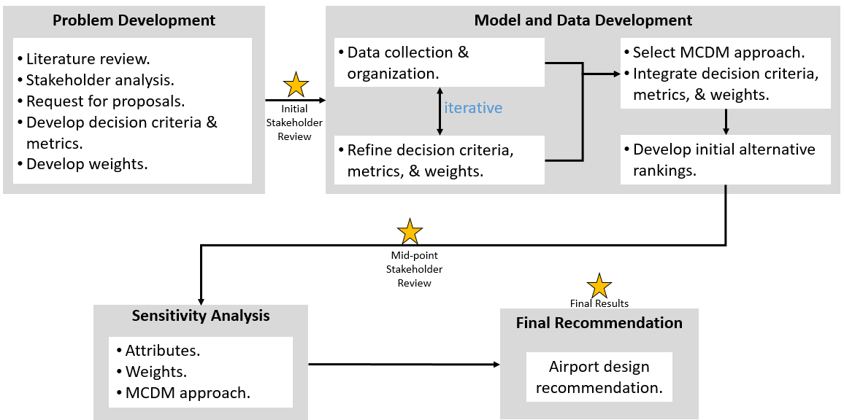

Figure 1. Methodology.

The first step in the methodology was problem development. This step was necessary to understand the problem, stakeholder positions, and identify the critical elements necessary to inform the airport design decision. As representatives for the larger stakeholder community, the Airport Selection Committee provided essential data for this effort. They identified the overall objective for the study, the goals for the new airport design, the decision criteria for the basis of the design, and specific metrics for each decision criteria. Additionally, members of the Airport Selection Committee provided their weights for each metric and decision criteria. Once the critical design goals were established, the Airport Selection Committee released a request for proposals to develop a set of alternatives for consideration.

Next, the team collected the responses from the request for proposal and began organizing the data in accordance with the Airport Selection Committee metrics. The team refined the decision criteria and metrics based on the available data. The refinement removed criteria that did not distinguish the alternatives. In addition, the team converted quantitative criteria to qualitative criteria where no hard data were available but the Airport Selection Committee could evaluate the alternative subjectively. This was an iterative process and included feedback from the Airport Selection Committee. Next, the team determined the appropriate MCDM approach and developed the model to assess the alternatives. The first run of the model produced the initial recommendation.

Lastly, the team conducted sensitivity analysis to identify the inputs whose variation have the most impact on the results and might change the recommendation. The team varied the values for the alternative data and the Airport Selection Committee weights, as well as applied different MCDM approaches. The team then considered all of the results to develop a final airport design alternative recommendation.

# Chapter 3 – Alternatives

## Purpose.

This chapter describes the minimum design criteria, provides an overview of the four alternatives, and outlines the type and pedigree of data collected for use in modeling. Chapters 4 through 6 will provide a detailed description of the modeling results and sensitivity analysis of this data.

## Minimum Design Criteria.

Exhibit L of the KCI Terminal Modernization Program, published in June of 2013, outlines the minimum design criteria for all alternatives. These criteria enabled the city, the airlines, the officials, and analysts responsible for the terminal modernization program as well as future competing companies to gain an understanding of the framework and expectations of the customer - the citizens of Kansas City.

KCI terminal design proposals must meet the following specifications:

1. Single terminal facility with a minimum of 750,000 square feet.
2. Minimum of 35 Airport Design Group (ADG) III-compliant gates.
3. Expansion potential to 42 ADG III-compliant gates.
4. Multi-level parking structure adjacent to the terminal with a minimum of 6,500 parking spaces.
5. Two-level terminal (arrivals and departures).
6. Separate commercial and passenger curb areas.
7. Total contract cost must not exceed $975 million (fiscal year (FY) 15 dollars).

Following the request for proposal process, the team identified four design alternatives for further analysis. These four alternatives fall into two categories: Functional vs. Iconic and 35 vs. 25 ADG III-compliant gates. Table 1 lists the alternatives by category. Chapter 5 provides the raw data for each alternative.

Table 1. Alternatives.

|  |  |  |
| --- | --- | --- |
| **Category** | **Functional Design** | **Iconic Design** |
| **35 Gates** | **Alternative 1.**  “Functional, Compliant.” | **Alternative 2.**  “Iconic, Compliant.” |
| **25 Gates** | **Alternative 3.**  “Functional, Reduced Compliant.” | **Alternative 4.**  “Iconic, Reduced Compliant.” |

## Alternative 1–Functional, Compliant Design.

Alternative 1 is a 750,000 square foot design with split-level arrivals and departures, a terminal-to-garage tunnel, 35 ADG III-compliant gates, 10 hardstand remain-overnight (RON) aircraft parking areas, and an attached 6,500-space parking garage. It includes 11 TSA security lanes, 265,408 square feet of airline operations space, and seven baggage claim carrousels. The total cost for Alternative 1 is $1.131 billion. Figure 2 and Figure 3 provide an illustration of the functional, compliant design alternative profile and overhead views, respectively (“Design, Construct and Private Financing of KCI”, 2017).



Figure 2. Alternative 1 Design (Profile).

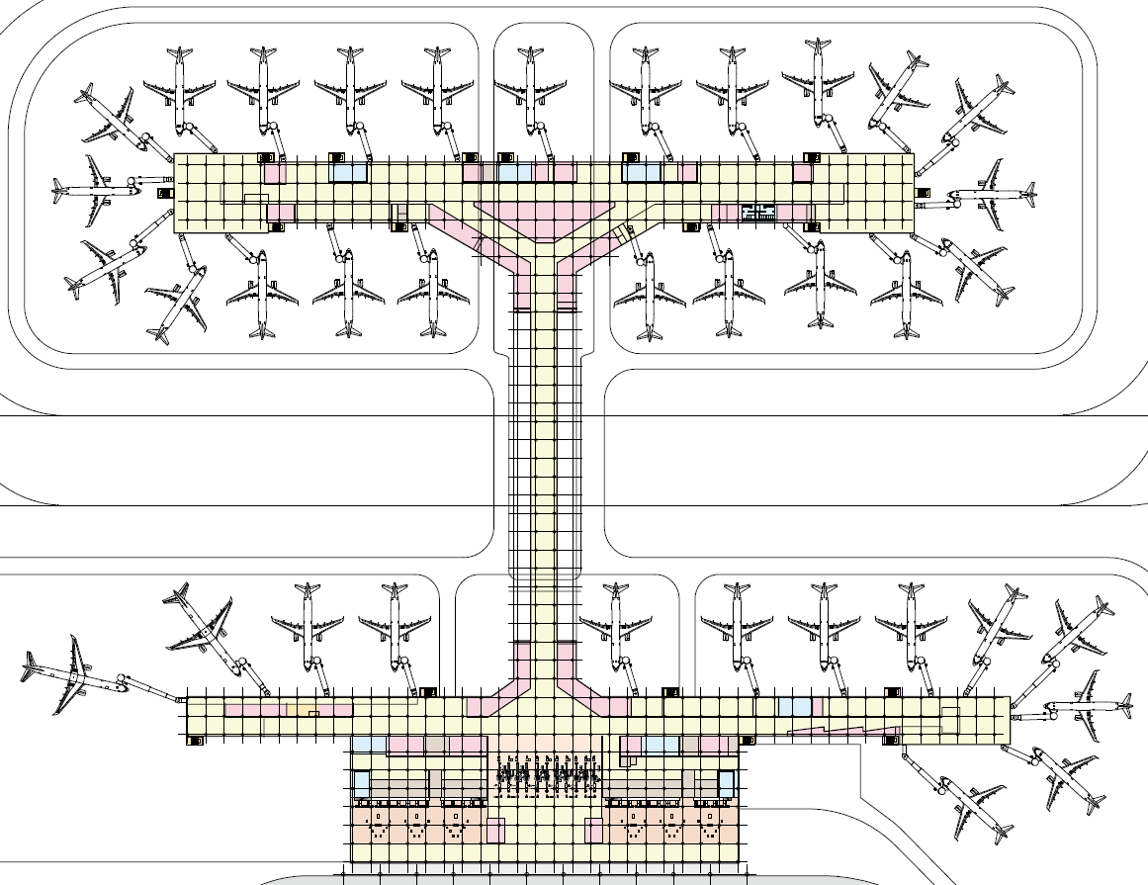

Figure 3. Alternative 1 Design (Overhead).

## Alternative 2–Iconic, Compliant Design.

Alternative 2 is a 738,247 square foot design with a two-story baggage claim, reduced ticketing area, an elevated pedestrian bridge to the parking garage, 35 ADG III-compliant gates, 10 hardstand RON aircraft parking areas, and an attached 6,500-space parking garage. It includes 12 TSA security lanes, 204,436 square feet of airline operations space, and three baggage claim carrousels. The total cost for Alternative 2 is $1.284 billion. Figure 4 and Figure 5 provide an illustration of the iconic, compliant design alternative profile and overhead views, respectively.



Figure 4. Alternative 2 Design (Profile).

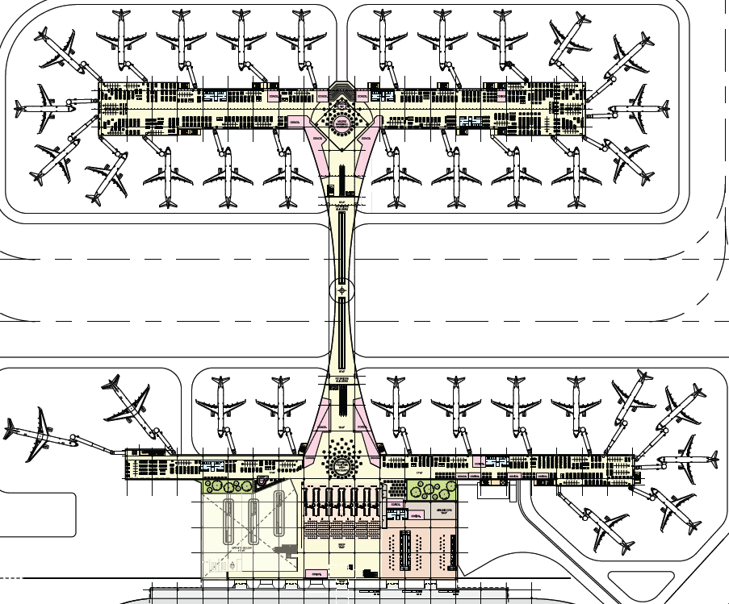

**Figure 5. Alternative 2 Design (Overhead).**

## Alternative 3–Functional, Reduced Compliant Design.

Alternative 3 is a 653,279 square foot design with reduced baggage claim and ticketing area, a terminal-to-garage tunnel, 25 ADG III-compliant gates, 20 hardstand RON aircraft parking areas, and an attached 4,500-space parking garage. It includes 11 TSA security lanes, 237,508 square feet of airline operations space, and seven baggage claim carrousels. The total cost for Alternative 2 is $0.953 billion. Figure 6 and Figure 7 provide an illustration of the functional, reduced compliant design alternative profile and overhead views, respectively.



Figure 6. Alternative 3 Design (Profile).

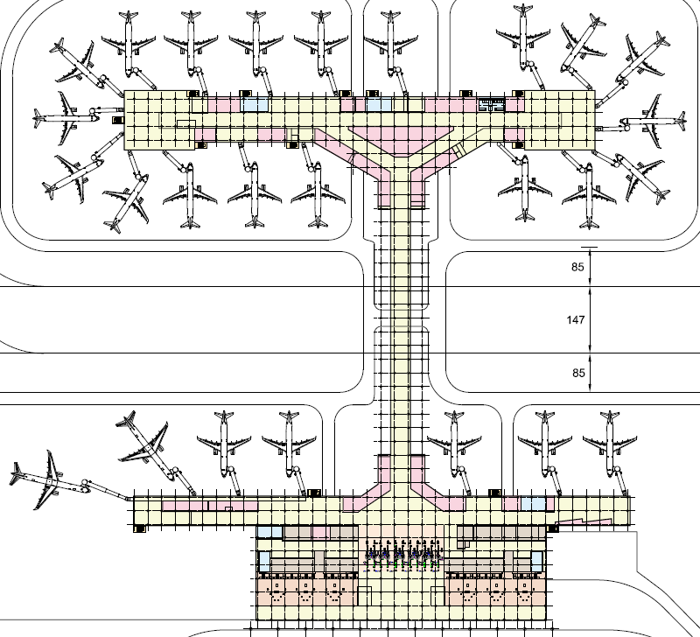

Figure 7. Alternative 3 Design (Overhead).

## Alternative 4–Iconic, Reduced Compliant Design.

Alternative 4 is a 657,745 square foot design with a two-story baggage claim, reduced ticketing area, an elevated pedestrian bridge to the parking garage, 25 ADG III-compliant gates, 20 hardstand RON aircraft parking areas, and an attached 4,500-space parking garage. It includes 12 TSA security lanes, 171,436 square feet of airline operations space, and three baggage claim carrousels. The total cost for Alternative 4 is $1.122 billion. Figure 8 and Figure 9 provide an illustration of the functional, reduced compliant design alternative profile and overhead views, respectively.



Figure 8. Alternative 4 Design (Profile).

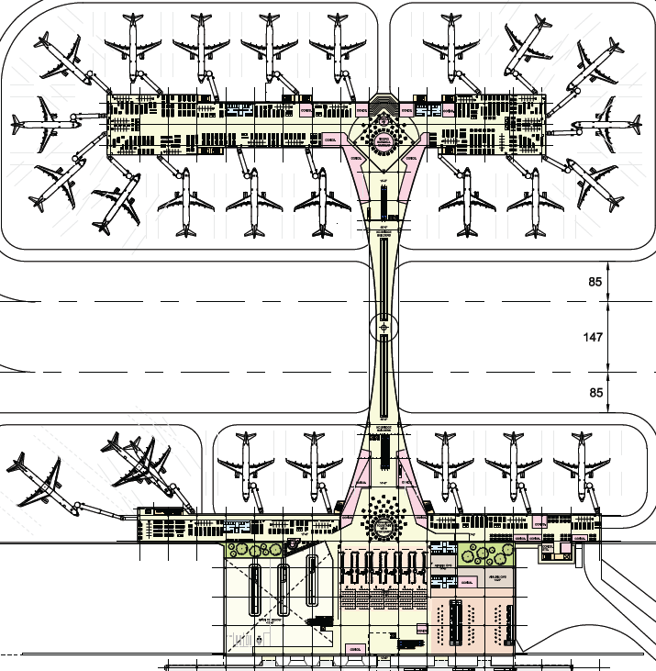

Figure 9. Alternative 4 Design (Overhead).

## Data Screening and Refinement.

Contractor-provided design specifications serve as the source for alternative data. Some of the data does not meet the minimum design specifications; however, in these cases, the contractors used analysis of flight and passenger projections to identify potential cost savings in their designs. These reduced compliant designs rely on smaller initial designs to meet projected opening day demands and thereby realize cost savings while maintaining the potential to expand as demand increases.

Working with the Airport Selection Committee, the team identified the set of decision criteria and metrics relevant to informing the design selection decision. Chapters 4 and 5 describe the weighting and data development, respectively.

# Chapter 4 – Model Development

## Purpose.

This chapter describes the objectives and decisions criteria used in the MCDM problem, identifies the corresponding importance weightings, and details the steps used by the consulting team in applying the Technique of Order Preference Similarity to the Ideal Solution (TOPSIS) method.

## Objectives and Decision Criteria.

The City Council of Kansas City, MO, received multiple proposals from numerous contractors upon making their intentions known to the public. Their objective was clear: to select a contractor and associated proposal and build a new single terminal that enhances the role of Kansas City by providing a high level of air service as well as a source of community pride. The City rejected some of the contractor proposals due to lack of data while advancing four alternatives to the consulting team for analysis.

After consulting with key stakeholders, the consulting team decomposed the overall objective to choose a new redesign into the following five sub-objectives:

1. **Terminal Interior**: Develop a cost-efficient, safe, customer friendly, future-oriented terminal interior design that meets the needs of the airlines, passengers, and employees.
2. **Air Operations Throughput**: Increase efficiency of air terminal operations and improve on-time performance.
3. **Regional and Landside Access**: Increase efficiency of all landside endeavors from entry highways to airport entrance.
4. **Airport Revenue**: Balance operating costs with airport profit.
5. **Contractor Feasibility**: Contractor ability to meet construction timelines within cost.

This set of sub-objectives adequately captures the breadth of the design problem while decomposing the decision into subcomponents required for quantitative analysis. The consulting team then decomposed each sub-objective into a set of decision criteria which was briefed to the City Council on September 25th, 2017. Data analysis identified the set of decision criteria that did not distinguish among the alternatives. The City Council endorsed the final set of sub-objectives and decision criteria, outlined in Table 2, on October 30th, 2017.

Table 2. Sub-objectives and Decision Criteria.

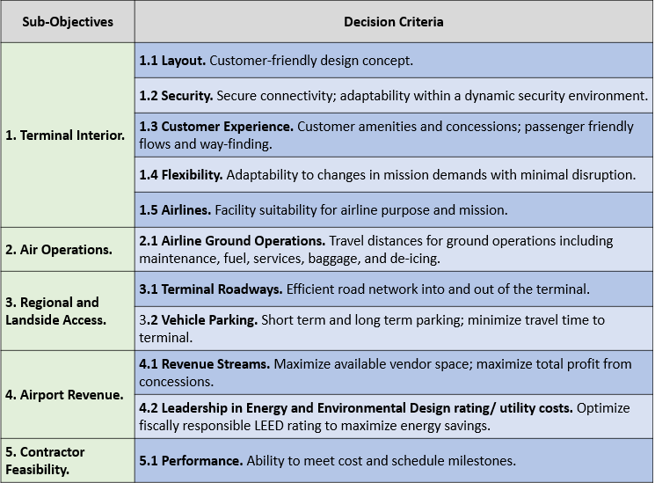

## Importance Weights.

With the objectives, decision criteria, and attributes of the alternatives all known, the final data element required to begin MCDM is the importance weights for each sub-objective and each decision criteria. Each member of the City Council represents different positions, groups of voters, and serves a different role on the council. The consulting team solicited the individual weighting preferences of each of the KCI Airport Selection Committee members. The overall weight for each sub-objective and each decision criteria was determined by taking the average of the individual committee member’s assessed weight for each component of the model. Table 3 presents the decision maker’s individual weights and the final overall weights used for the sub-objectives.

Table 3. Sub-objective Importance Weights.

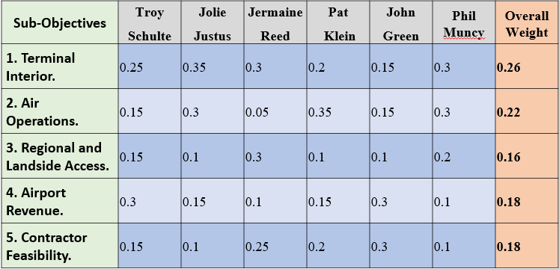

The consulting team solicited and averaged decision criteria weights from the decision makers to compute the importance weights for the decision criteria. The final metric weight is the product of the governing sub-objective weight, the decision criteria, and the equally weighted metric. For example, the weight of the departure flow metric is calculated as follows: terminal interior (0.26) x layout (0.19) x departure flow (0.5) results in a metric weight of 0.025. Table 4 presents the final weighting scheme used in the MCDM for all sub-objectives, decision criteria, and metrics.

Table 4. Weighting Scheme.

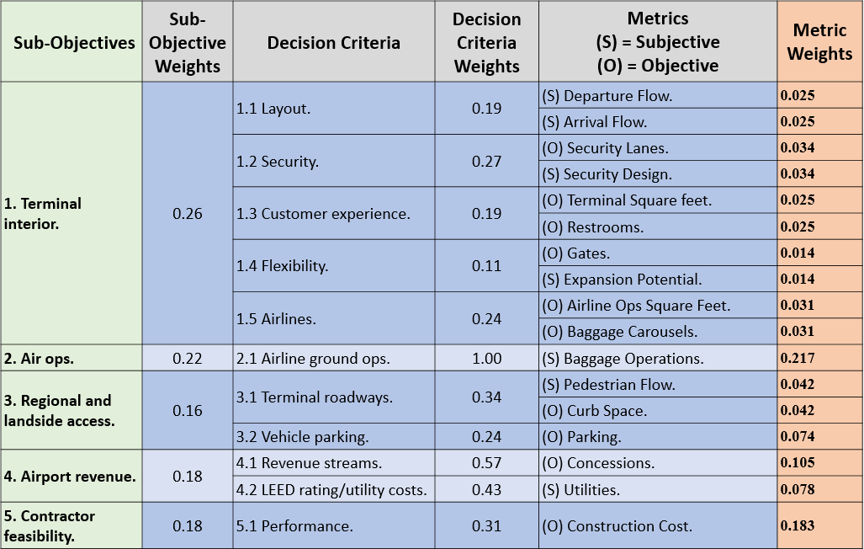

## MCDM Model.

The consulting team identified the TOPSIS method as the most suitable MCDM method to enable this decision. This method enabled the team to blend (normalize) subjective and objective measures of the decision criteria and metrics into the same model to compare them on equivalent, unitless scales. The TOPSIS method then computes a positive and negative ideal solution for each criteria. When complete, the model provides a measure of closeness to the ideal solution (and the compliment- the distance from the anti-ideal solution). Model output is the weighted, rank ordered list of alternatives based on the value of the relative closeness coefficient. A general description of the process follows:

Given a set of *m* alternatives with *n* decision criteria (or attributes) with *a* performance of the attributes: (Ishizaka, Nemery, 2013 p. 215-219)

**Step 1:** Create an *m x n* decision matrix,, that contains the raw values of all attributes (decision criteria) of the alternatives. Identify each decision criteria as either a benefit attribute (more is better) or a cost attribute (less is better).

**Step 2:** Normalize the attributes of the alternatives using *distributed normalization (vector normalization)*.

,

where is the normalized value; is the raw value of the attribute.

**Step 3:** Weight the normalized decision matrix based on the weights of each attribute, as assessed by the decision maker.

where is the weighted value of and is the weight of the attribute.

**Step 4:** Calculate the positive ideal solution (PIS) and the negative ideal solution (NIS) for every attribute of the alternatives.

**Step 5:** Calculate the Euclidean distance of each alternative to the PIS and to the NIS.

For the distance to the PIS:

For the distance to the NIS:

**Step 6:** Calculate the relative closeness coefficient of each action:

where is the relative closeness coefficient.

**Step 7:** Rank order the alternatives based on their relative closeness coefficient.

**Step 8:** Conduct sensitivity analysis on the attribute weights and the raw data to identify when alternatives overtake the ranking alternative for each attribute.

**Step 9:** Synthesize the data and conclusions in a manner that provides utility to the decision maker.

The next chapter provides the raw data associated with this decision problem and demonstrates the use of the TOPSIS model as the consulting team worked to provide a recommendation to the Kansas City Airport Selection Committee.

# Chapter 5 – Initial Results

## Purpose.

This chapter provides an overview of the raw data for the metrics of each alternative, initial results of the TOPSIS model, and the consulting team’s initial recommendations.

## Raw Data Scores.

The consulting team obtained the raw data for objective metrics from the KCI Partnership Request for Proposal responses (“Design, Construct, and Private Financing of KCI”, 2017). The Airport Selection Committee members (fictitiously) provided ratings via a 5-point Likert scale on the subjective metrics. The consulting team screened 26 of the initial 43 metrics because the data did not distinguish between alternatives for the attribute in question. Table 5 depicts the raw data scores. The “Metrics” column indicates if a metric is objective or subjective by (O) and (S), respectively. The “Benefit or Cost” column indicates if a metric was maximized, a benefit attribute, or minimized, a cost attribute, to obtain the optimal solution.

Table 5. Rata Data Scores.

| **Sub-Objectives** | **Decision Criteria** | **Metrics** | **Benefit or Cost** | ***Functional Compliant 35*** | ***Iconic Compliant 35*** | ***Functional Reduced 25*** | ***Iconic Reduced 25*** |
| --- | --- | --- | --- | --- | --- | --- | --- |
| **1. Terminal Interior.** | 1.1 Layout. | (S) Departure Flow. | Benefit | 4.25 | 4 | 4.25 | 4 |
| (S) Arrival Flow. | Benefit | 4.5 | 4.25 | 4.5 | 4.25 |
| 1.2 Security. | (O) Security Lanes. | Benefit | 11 | 12 | 11 | 12 |
| (S) Security Design. | Benefit | 4.5 | 4.25 | 4.25 | 4 |
| 1.3 Customer Experience. | (O) Terminal Area (sq. ft.) | Benefit | 750000 | 738247 | 653279 | 657745 |
| (O) Restrooms. | Benefit | 77 | 56 | 49 | 49 |
| 1.4 Flexibility. | (O) Gates. | Benefit | 35 | 35 | 25 | 25 |
| (S) Expansion Potential. | Benefit | 4 | 3.5 | 3.75 | 3.5 |
| 1.5 Airlines. | (O) Airline Ops Area (sq. ft.) | Benefit | 265408.4 | 204436.3 | 237508.4 | 171436.3 |
| (O) Baggage Handling. | Benefit | 7 | 3 | 7 | 3 |
| **2. Air Ops.** | 2.1 Airline Ground Ops. | (S) Baggage Claim. | Benefit | 3.5 | 4 | 3.5 | 4 |
| **3. Regional and Landside Access.** | 3.1 Terminal Roadways. | (S) Pedestrian Flow. | Benefit | 3.5 | 4.5 | 3.5 | 4.5 |
| (O) Curb Space. | Benefit | 62386 | 76565 | 62386 | 76565 |
| 3.2 Vehicle Parking. | (O) Parking. | Benefit | 6500 | 6500 | 4500 | 4500 |
| **4. Airport Revenue.** | 4.1 Revenue Streams. | (O) Concessions. | Benefit | 58590 | 27825 | 53940 | 27575 |
| 4.2 LEED rating/ utility costs. | (S) Utilities. | Benefit | 3 | 2.5 | 4 | 3.25 |
| **5. Contractor Feasibility.** | 5.1 Performance. | (O) Construction Cost. | Cost | $1.131B | $1.284B | $0.953B | $1.122B |

## Initial Results.

To use the TOPSIS method to determine the ideal solution, the consulting team converted the raw data into normalized and weighted scores. This transforms the attributes into non-dimensional attributes, which allows for comparisons across metrics. Table 6 shows the weights derived from the decision makers’ initial scoring of the metrics as well the normalized and weighted score per metric for each alternative.

Table 6. Weighted Normalized Scores.

|  |  |  |  |  |  |  |  |  |
| --- | --- | --- | --- | --- | --- | --- | --- | --- |
| **Sub-Objectives** | **Decision Criteria** | **Metrics** | **Weight** | **Benefit**  **or Cost** | ***Functional Compliant 35*** | ***Iconic Compliant 35*** | ***Functional Reduced 25*** | ***Iconic Reduced 25*** |
| **1. Terminal Interior.** | 1.1 Layout. | Departure Flow. | 0.025 | Benefit | 0.013 | 0.012 | 0.013 | 0.012 |
| Arrival Flow. | 0.025 | Benefit | 0.013 | 0.012 | 0.013 | 0.012 |
| 1.2 Security. | Security Lanes. | 0.034 | Benefit | 0.016 | 0.018 | 0.016 | 0.018 |
| Security Design. | 0.034 | Benefit | 0.018 | 0.017 | 0.017 | 0.016 |
| 1.3 Customer Experience. | Terminal Area (sq. ft.) | 0.025 | Benefit | 0.013 | 0.013 | 0.012 | 0.012 |
| Restrooms. | 0.025 | Benefit | 0.016 | 0.012 | 0.010 | 0.010 |
| 1.4 Flexibility. | Gates. | 0.014 | Benefit | 0.008 | 0.008 | 0.006 | 0.006 |
| Expansion Potential. | 0.014 | Benefit | 0.008 | 0.007 | 0.007 | 0.007 |
| 1.5 Airlines. | Airline Ops Area (sq. ft.) | 0.031 | Benefit | 0.019 | 0.014 | 0.017 | 0.012 |
| Baggage Handling. | 0.031 | Benefit | 0.020 | 0.009 | 0.020 | 0.009 |
| **2. Air Ops.** | 2.1 Airline Ground Ops. | Baggage Claim. | 0.217 | Benefit | 0.101 | 0.115 | 0.101 | 0.115 |
| **3. Regional and Landside Access.** | 3.1 Terminal Roadways. | Pedestrian Flow. | 0.042 | Benefit | 0.018 | 0.024 | 0.018 | 0.024 |
| Curb Space. | 0.042 | Benefit | 0.019 | 0.023 | 0.019 | 0.023 |
| 3.2 Vehicle Parking. | Parking. | 0.074 | Benefit | 0.043 | 0.043 | 0.030 | 0.030 |
| **4. Airport Revenue.** | 4.1 Revenue Streams. | Concessions. | 0.105 | Benefit | 0.070 | 0.033 | 0.064 | 0.033 |
| 4.2 LEED rating/ utility costs. | Utilities. | 0.078 | Benefit | 0.036 | 0.030 | 0.048 | 0.039 |
| **5. Contractor Feasibility.** | 5.1 Performance. | Construction Cost. | 0.183 | Cost | 0.092 | 0.104 | 0.077 | 0.091 |

The Functional Reduced 25 alternative scored as the top alternative after executing the TOPSIS model. The Functional Compliant 35 ranked as the second best alternative and scored relatively closely to the first place alternative. Both Iconic alternatives scored poorly when compared to the Functional alternatives as shown in Table 7.

Table 7. TOPSIS Results.

|  |  |  |  |  |
| --- | --- | --- | --- | --- |
| **TOPSIS Results** | ***Functional Compliant 35*** | ***Iconic Compliant 35*** | ***Functional Reduced 25*** | ***Iconic Reduced 25*** |
| **S\*** | 0.025 | 0.051 | 0.023 | 0.045 |
| **S-** | 0.044 | 0.021 | 0.047 | 0.023 |
| **Relative Score C\*** | **0.641** | **0.295** | **0.675** | **0.334** |
| **Rank** | 2 | 4 | 1 | 3 |

Despite having less gates than requested and other attributes that did not quite meet the guidelines presented in the Memorandum of Understanding (“Memorandum of Understanding”, 2017), the Functional Reduced 25 gates ranked first based on the decision makers’ weights and the design’s attributes. Many attributes or metrics that are common to the Functional designs led to these two alternatives significantly outweighing both Iconic designs.

The consulting team recommends that the Selection Committee pursue the Functional Reduced 25 gates design. This design is based on future flight and passenger projections which drove the design team to “right-size” the requirements to meet opening day demand while accommodating the near-term growth of the terminal (“Design, Construct and Private Financing of KCI”, 2017). For a lower initial annual fixed payment, a reduced annual terminal operating cost, and a square footage footprint that meets opening day demands, the Functional Reduced 25 design provides a more optimal solution than its Functional Compliant 35 design counterpart while allowing for expansion in the future.

The consulting team conducted sensitivity analysis to determine which attributes have the most impact between the Functional Compliant 35 and Functional Reduced 25 and if any attributes have enough impact to bring either Iconic design alternative within range of the Functional design alternatives. This analysis is discussed in Chapter 6.

# Chapter 6 – Sensitivity Analysis

## Purpose.

This chapter discusses the sensitivity analysis. As the previous chapter described, the top ranked alternative was the Functional Reduced 25. This sensitivity analysis explored potential “what-if” situations and determined when the recommendation would change. The team analyzed the sensitivity of the results based on: 1) sub-objective weights, 2) metric weights, 3) alternative performance, and 4) the MCDM prioritization method.

## Sub-Objective Weights.

The team changed the weight of each sub-objective independently to see at what point the top ranked alternative changed. Increasing or decreasing the relative weight of a sub-objective could potentially change the results. This is why there is a lower and upper bound. If the weight of the sub-objective under analysis decreased below the lower bound or increased above the upper bound, the top ranked alternative changed. Where the lower bound was 0, the results were not sensitive to a decrease in that sub-objective weight. Likewise, where the upper bound was 1, the results were not sensitive to an increase in that sub-objective weight. Table 8 shows the results in table format, and Figure 10 shows the same values on a chart. The y-axis of Figure 10 ends at a value of 0.5, as all upper bounds that exceed that value extend all the way to 1.0.

Table 8. TOPSIS Model with New Sub-objective Weights.

|  |  |  |  |  |
| --- | --- | --- | --- | --- |
| **Sensitivity:**  **Ejection from Top 1** | **Calculated Weights** | **Lower Sensitivity Bound** | **Upper Sensitivity Bound** | **New Top Alt.** |
| **1. Terminal Interior.** | 0.26 | 0.0000 | 0.4000 | Complaint 35 |
| **2. Air Operations Throughput.** | 0.22 | 0.0000 | 0.4500 | Iconic 25 |
| **3. Regional and Landside Access.** | 0.16 | 0.0000 | 0.2000 | Complaint 35 |
| **4. Airport Revenue.** | 0.18 | 0.0000 | 1.0000 | N/A |
| **5. Contractor Feasibility.** | 0.18 | 0.1400 | 1.0000 | Complaint 35 |

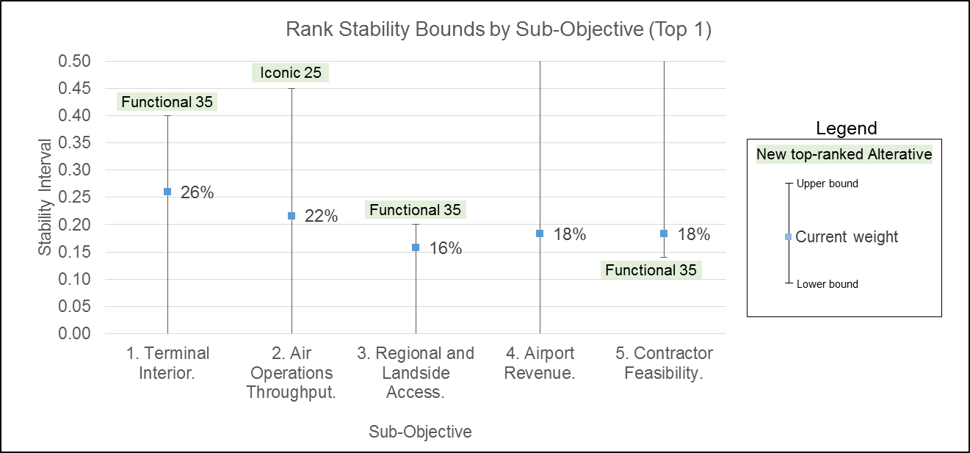

Figure 10. Recommendation Sensitivity to Sub-Objective Weights.

Discussion of Results. The alternatives’ scores and resulting rankings were sensitive to changes in sub-objective weights. If the terminal interior weight increased above 0.4 or if the regional and landside access weight increased above 0.2, the Functional 35 was the new top alternative. The key drivers for the Functional 35 in these areas were the additional terminal interior space and additional parking. If the contractor feasibility weight decreased below 0.14, the Functional 35 became the new top alternative. Less emphasis on construction costs drove this higher priced alternative to rank first in this case. Lastly, if the air operations throughput weight increased to 0.45, the Iconic 25 became the new top alternative. With the Iconic design, the pedestrian bridge did not divide the terminal ramp space and hamper airline operations, giving the Iconic design an advantage in air operations throughput. Looking across all the sub-objectives, the top alternative was most sensitive to changes in regional and landside access and contractor feasibility. In both cases, just a small change of 0.04 was required for the Functional 35 to overtake the Functional 25 as the top alternative.

## Metric Weights.

Similar to sensitivity analysis for the sub-objective weights, the team changed the weight of each metric independently to see at what point the top ranked alternative changed. Again, where the lower bound was 0, the results were not sensitive to a decrease in that sub-objective weight. Likewise, where the upper bound was 1, the results were not sensitive to an increase in that sub-objective weight. Table 9 shows the results in table format, and Figure 11 shows the same values on a chart. The y-axis of Figure 11 ends at a value of 0.5, as all upper bounds that exceed that value extend all the way to 1.0.

Table 9. TOPSIS Model with New Metric Weights.

|  |  |  |  |
| --- | --- | --- | --- |
| **Sensitivity:**  **Ejection from Top 1** | **Calculated Weights** | **Upper Bound** | **Lower Bound** |
| Departure Flow. | 0.0248 | 0.4457 | 0.0000 |
| Arrival Flow. | 0.0248 | 1.0000 | 0.0000 |
| Security Lanes. | 0.0344 | 0.4889 | 0.0000 |
| Security Design. | 0.0344 | 0.2551 | 0.0000 |
| Terminal Area | 0.0248 | 0.1486 | 0.0000 |
| Amenities. | 0.0248 | 0.0533 | 0.0000 |
| Gates. | 0.0140 | 0.0660 | 0.0000 |
| Expansion Potential. | 0.0140 | 0.2239 | 0.0000 |
| Airline Ops. Area | 0.0312 | 0.1239 | 0.0000 |
| Baggage Handing. | 0.0312 | 1.0000 | 0.0000 |
| Baggage Ops (plane-side). | 0.2167 | 0.4507 | 0.0000 |
| Pedestrian Flow. | 0.0422 | 0.2536 | 0.0000 |
| Curb Space. | 0.0422 | 0.2910 | 0.0000 |
| Parking. | 0.0739 | 0.0974 | 0.0000 |
| Concession. | 0.1054 | 0.1596 | 0.0000 |
| Utilities. | 0.0779 | 1.0000 | 0.0402 |
| Construction Cost. | 0.1833 | 1.0000 | 0.1418 |

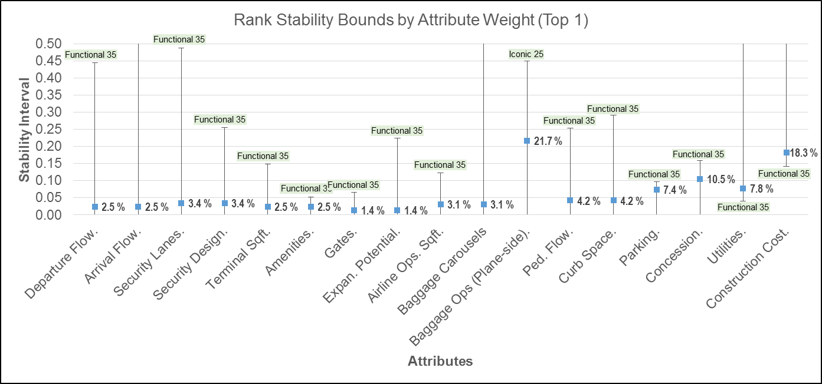

Figure 11. Recommendation Sensitivity to Metric Weights.

Discussion of Results. The alternatives’ scores and resulting rankings were sensitive to changes in metric weights. Thirteen of the metrics were sensitive to changes in their weights above the upper bound and resulted in a new top alternative. In twelve of the thirteen cases, the new top alternative was the Functional 35. This was because the larger, 35-gate terminal scored well in metrics where more or bigger was better. Additionally, the space that the larger design provided improved flow by reducing bottlenecks. The one case where an increase did not favor the Functional 35 was Baggage Ops (planeside), where an increase in its weight above the upper bound made the Iconic 25 the top alternative. The new top alternative was the Functional 35; the exception is Baggage Ops (planeside), where an increase in its weight above the upper bound made the Iconic 25 the top alternative. Unlike the Functional designs, the pedestrian bridge for the Iconic designs did not hamper Baggage Ops. A decrease in the weight of the utilities or construction cost below the lower bound made the Functional 35 the top scoring alternative again due to less emphasis on an alternative with higher associated costs.

**Alternative Performance.** The team analyzed the sensitivity of the results to the performance of the alternatives in the two highest weighted attributes: baggage operations and cost. Specifically, the team determined the changes necessary for another alternative to overtake the Functional 25 as the top alternative.

Discussion of Results. Baggage Operations Efficiency was the highest weighted metric. Reducing the Likert scores of the Functional designs from 3.5 to 2.7 moved the Iconic 25 design into first place and dropped the Functional 35 to last place. Table 10 shows the original and new Likert scores and overall score and rank. Note that the team changed the scores for both Functional designs as their baggage handling plans are the same.

Table 10. Sensitivity to Functional 25 Baggage Operations Reduced Score.

|  |  |  |  |  |  |  |
| --- | --- | --- | --- | --- | --- | --- |
|  | **Original Likert** | **New Likert** | **Original Score** | **Original Rank** | **New Score** | **New Rank** |
| **Functional 35** | 3.5 | 2.7 | 0.641 | 2 | 0.473 | 4 |
| **Iconic 35** | 4 | 4 | 0.294 | 4 | 0.484 | 3 |
| **Functional 25** | 3.5 | 2.7 | 0.675 | 1 | 0.493 | 2 |
| **Iconic 25** | 4 | 4 | 0.334 | 3 | 0.517 | 1 |

Discussion of Results. Cost was the second highest weighted metric. Increasing the cost of the Functional Reduced 25 by $52.3M (5.5%) or decreasing the cost of the Functional 35 by $64.9M (5.7%, not shown) moved the Functional 35 design into first place. Table 11 shows the original and new cost and overall score for these two alternatives when increasing the Function Reduced 25 cost.

Table 11. Sensitivity to Functional 25 Cost Increase.

|  |  |  |  |  |
| --- | --- | --- | --- | --- |
|  | **Original Cost ($)** | **New Cost ($)** | **Original Score** | **New Score** |
| **Functional 25** | 953,134,803 | 1,005,434,803 | 0.675 | 0.66301 |
| **Functional 35** | 1,131,127,076 | 1,131,127,076 | 0.641 | 0.66306 |
| **Difference** | (177,992,273) | (125,692,273) | 0.03335 | (0.00005) |

## MCDM Method.

Because TOPSIS is one of many MDCM prioritization methods, the team wanted to know if the ranking of the alternatives was sensitive to the method selected. The consulting team applied Simple Additive Weighting (SAW) and the Preference Ranking Organization Method for Enrichment of Evaluations (PROMETHEE). Figure 12 provides a side-by-side scoring of the alternatives using TOPSIS and SAW techniques.

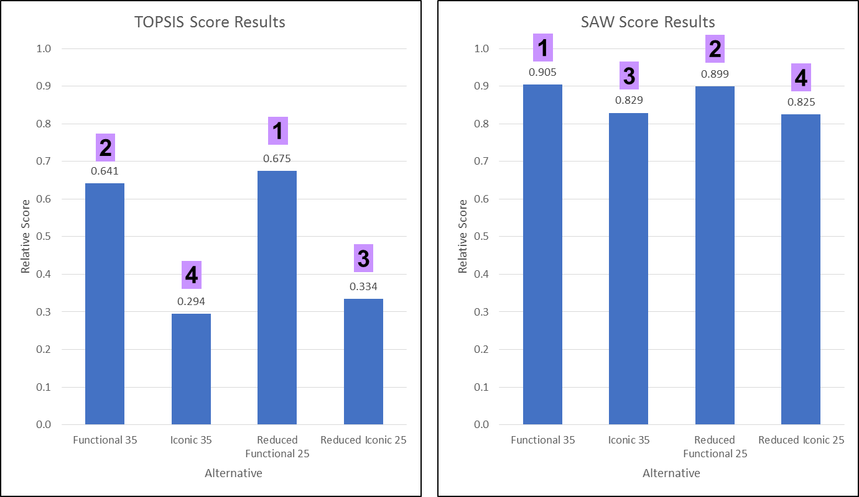

Figure 12. TOPSIS and SAW Results Comparison.

Discussion of SAW Results. With the SAW method, the results changed slightly. The Functional alternatives still scored higher than the Iconic alternatives. However, with SAW, the 35-gate versions scored slightly higher than the 25-gate versions, whereas with TOPSIS the opposite was true. Additionally, the difference in scores across the alternatives was closer for the SAW method. The consulting team believes this is due to the way that TOPSIS measures against the positive and negative ideals whereas SAW is based on the weighted average.

The team also scored and ranked the alternatives using the PROMETHEE method. Figure 13 provides a side-by-side scoring of the alternatives using TOPSIS and PROMETHEE.

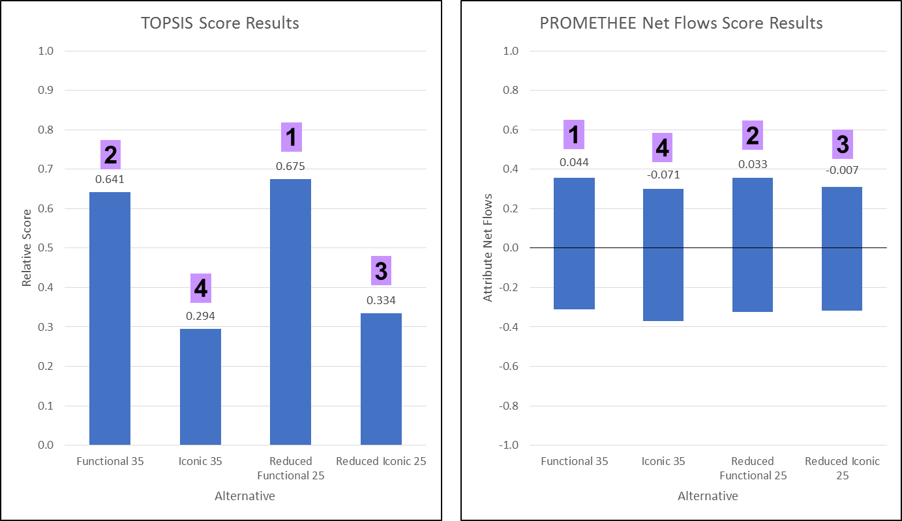

Figure 13. TOPSIS and PROMETHEE Results Comparison.

Discussion of PROMETHEE Results. With the PROMETHEE method, the results changed slightly. The Functional 35 became the new top alternative but only by a narrow margin. The 3rd and 4th place rankings remained the same. Similar to the SAW method, the difference in scores across the alternatives was closer for the PROMETHEE method. Same as above, the consulting team believes that this is due to the way that TOPSIS measures against the positive and negative ideals whereas PROMETHEE is based on the decision maker’s preference degrees between the values of each alternatives’ metrics.

# Chapter 7 – Conclusion

## Purpose.

This chapter summarizes the KCI single terminal design selection results. In addition, this chapter discusses Midland Consulting’s recommendation for the single terminal design and team lessons learned.

## Summary of Findings.

The consulting team recommends that the Airport Selection Committee pursue the Functional Reduced 25 design. This design is based on future flight and passenger projections which drove the design team to “right-size” the requirements to meet opening day demand while accommodating the near-term growth of the terminal (“Design, Construct and Private Financing of KCI”, 2017). For a lower initial annual fixed payment, a reduced annual terminal operating cost, and a square footage footprint that meets opening day demands, the Functional Reduced 25 design provides a more optimal solution than its Functional Compliant 35 design counterpart while allowing for expansion in the future. Table 10 lists the rankings and scores for each alternative.

Table 12. Final Design Rankings and TOPSIS Scores.

|  |  |  |  |  |
| --- | --- | --- | --- | --- |
| **Rank** | **1** | **2** | **3** | **4** |
| **TOPSIS Score** | 0.675 | 0.641 | 0.334 | 0.294 |
| **Alternative** | Functional Reduced 25 | Functional Compliant 35 | Iconic  Reduced 25 | Iconic Compliant 35 |

Sensitivity analysis offered insights into the data and the terminal design rankings. The consulting team analyzed the sensitivity of the results based on the 1) sub-objective weights, 2) metric weights, 3) alternative performance, and 4) the MCDM method. Generally, both Functional terminal designs remained ranked in either first or second place and both Iconic terminal designs ranked in third or fourth regardless of the modifications made through sensitivity analysis. In many cases, the sensitivity of the data caused the Functional Compliant 35 design to overtake the Functional Reduced 25 design; however, the sensitivity analysis conducted by the consulting team did not offer enough evidence to alter the team’s recommendation of the Functional Reduced 25 design.

## Summary of Project Team Lessons.

The consulting team does not believe it violated any of the seven rules, shown in Table 11, for laying the groundwork when establishing a MCDM problem (Cassone, Tillman, 2008). Overall, decision makers would have easily understood the methods and processes. The TOPSIS model enabled the team to offer both solutions and sensitivity analysis within the timeframe of the project, and the model was adaptable and linked to corporate objectives. If this were a project within industry or the government, the team would have been able to coordinate with decision makers or other experts within the field to collect data on the subjective measures used within the model. Additionally, when conducting sensitivity analysis, SAW and PROMETHEE both produced a different top result than TOPSIS. The team chose to give the final recommendation based on the TOPSIS results due to the larger differential of the relative scores of the alternatives when compared to the other methods. However, if this project were for industry or the government, it would be prudent for the consulting team to re-evaluate which MCDM method was utilized and why, given this disparity.

Table 13. Rules for MCDM Problems.

|  |  |
| --- | --- |
| Rule | |
| 1. | Are the methods used understandable? |
| 2. | Is the overall decision making process easy to understand? |
| 3. | Does the model fit in the time frame? |
| 4. | Is the model adaptable? |
| 5. | Does the model link to corporate objectives? |
| 6. | Do expert opinions substitute lack of data? |
| 7. | Definition of the optimal solution. |

Another lesson learned from the project pertains to the weighting of the metrics after the team applied the raw data and reduced the metric list. In the cases of decision criteria 2.1 (airline ground operations) and decision criteria 5.1 (performance), both decision criteria had one associated metric. The metrics in both cases received 100% of that decision criteria’s weight and subsequently that sub-objective’s weight, causing those two metrics to comprise 40% of the metric weighting and significantly outweigh the remaining 15 metrics. The consulting team would have presented this to the selection committee, given a real world MCDM problem, and offered courses of action to redistribute the weights if the selection committee agreed.

The team will take these lessons learned and insights into the potential shortcomings forward into future MCDM studies.

### Study References

*About the City Manager’s Office* (2016, November 1). Retrieved from <http://kcmo.gov/citymanagersoffice/about/>.

*Borda Count* (2017, November 3). Retrieved from <https://en.wikipedia.org/wiki/Borda_count>.

*City Appoints Patrick Klein Director of Aviation* (2016, April 22). Retrieved from <http://kcmo.gov/news/2016/city-appoints-patrick-klein-director-of-aviation/>.

*City Council Members* (2015, December 1). Retrieved from <http://kcmo.gov/city-officials/city-council-members/>.

*Design, Construct and Private Financing of KCI. Retrieved from:* <http://media.kansascity.com/livegraphics/2017/pdf/kcipartnership.pdf>.

*Exhibit L Memorandum of Understanding Terminal Modernization Program.* Retrieved from: <http://www.flykci.com/media/1630/exhibit-l-mou-2017.pdf>.

Ishizaka, A., & Nemery, P. (2013). *Multi-criteria decision analysis: methods and software*. John Wiley & Sons.

*Kansas City Airport Customer Reviews* (2017, November 21). Retrieved from <http://www.airlinequality.com/airport-reviews/kansas-city-airport/>.

*Kansas City International Airport Traffic and Operations* (2016, December 1). Retrieved from <http://www.flykci.com/media/1583/stats-2016-december.pdf>.

Memorandum of Understanding Terminal Modernization Program: Exhibit L (2017). Retrieved from: <http://www.flykci.com/media/1630/exhibit-l-mou-2017.pdf>.

*The why of KCI: A broken plan that many travelers still love (2014, March 8).* Retrieved from <http://www.kansascity.com/news/politics-government/article341740/The-why-of-KCI-A-broken-plan-that-many-travelers-still-love.html>.

*Terminal Area Master Plan* (2015 April 1). Retrieved from <https://www.flykci.com/media/1446/mci-terminal-area-master-plan-april-2015-final.pdf>.

*Terminal Master Plan* (2013, May 1). Retrieved from <http://www.flykci.com/newsroom/terminal-master-plan/>.

Tillman, F., A, Cassone, D., T. (2015). *The Science of Common Sense: Best Practical Decision Science Methods*. HTX, Incorporated.

*Transportation Security Administration* (2017, November 28). Retrieved from <https://en.wikipedia.org/wiki/Transportation_Security_Administration/>.

*Voting and Social Choice* (2016, January 1). Retrieved from <http://www1.fee.uva.nl/creed/pdffiles/MoulinCh4Elferink.pdf>.

*4th District Councilwoman Jolie Justus* (2015, December 1). Retrieved from <http://kcmo.gov/justus/>.

### **Glossary**

|  |  |
| --- | --- |
| ADG | Airport Design Group |
| CLA | Constraints, Limitations, and Assumptions |
| FY | Fiscal Year |
| GDMT | Group Decision Making Techniques |
| GDMT | Group Decision Making Techniques |
| KCI | Kansas City International |
| LEED | Leadership in Energy and Environmental Design |
| MCDM | Multi-Criteria Decision Making |
| MO | Missouri |
| NIS | Negative Ideal Solution |
| O | Objective |
| Ops | Operations |
| PIS | Positive Ideal Solution |
| PROMETHEE | Preference Ranking Organization Method for Enrichment of Evaluations |
| RON | Remain-overnight |
| S | Subjective |
| SAW | Simple Additive Weighting |
| Sq. ft. | Square Feet |
| TOPSIS | Technique for Order of Preference by Similarity to Ideal Solution |
| TSA | Transportation Security Administration |
| US | United States |

1. Members of Team 1 played the role of the Airport Selection Committee throughout this project.